NEWTON’S LIMIT:
Gábor:
It may even happen that the inertial mass and the gravitational mass of bodies are not always equivalent.
Supporter:
That is not true! Nonsense! This has been established since Newton; for 400 years no one has questioned it. Loránd Eötvös proved it with his torsion balance.
Gábor:
Now listen!
Let us once again consider a thought experiment similar to the previous one!
PREPARATION:
As before, two people, the Supporter and Gábor, are standing in space outside the flying saucer, at rest relative both to the center of rotation of the saucer and to the fixed stars. We mount two identical iron balls on the two ends of a spiral spring. Their total mass is m. We push the two iron balls together until they touch, stretching the spiral spring. We fix the two iron balls to each other. We manufacture many identical pairs of balls (as many as fit along the circumference of a flying saucer).
EXPERIMENT:
We place our ball pairs along the circumference of the flying saucer. The saucer is rotating; its tangential velocity is v, and the force required to keep it on a circular path is
F = m · v.
Then, using a suitable device, we release the fixation of the ball pairs. The spiral spring pushes them apart; let us assume that, relative to the center of the spring, they start moving with velocity 2v, one in the direction of rotation and the other in the opposite direction.
From the rest frame, in the next instant we see the following: the combined center of mass of the two balls continues to orbit with velocity v; the ball pushed in the direction of motion orbits with velocity 3v, while the ball pushed in the opposite direction orbits with velocity v.
The force required to keep them on a circular path, in total:
F = (m/2) · v + (m/2) · 3v = 2m.
The inertial mass of the ball pair has doubled!
The diagram below shows the apparent increase in mass of the balls moving in a system rotating with tangential velocity v.
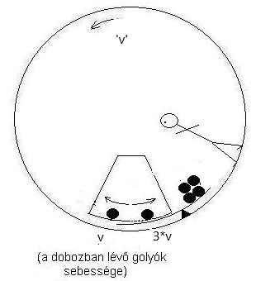v: balls’ velocity in the box

Supporter:
It seems like a marginal case! 😊 😊 Making iron balls oscillate inside a non-existent type of spacecraft! 😊
Gábor:
I used this example only to keep the formulation as simple as possible. The flying saucer represents any rotating system (a carousel, an engine, a centrifuge), and even any system moving along a curved path. The iron balls represent any body that contains moving parts (a gyroscope, a flywheel, or we may even think of the Brownian motion of atoms, in which the radial components of the motions cancel each other out, while the tangential components can be paired).
Supporter:
A gyroscope?
Gábor:
We attach our two iron balls used earlier to the two ends of a short rod, place a rotation axis at the center of the rod, and the spinning top is ready. I’ll draw it:
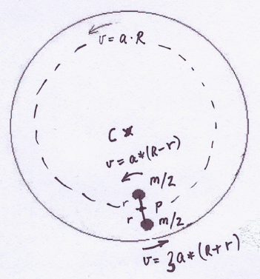

The gyroscope centered at P is orbiting along a circular path of radius R, centered at C. At the instant shown, the force acting on the P axis is:
F = (m/2) · 3a · (R + r) + (m/2) · a · (R − r)
= (m/2) · a · (3R + 3r + R − r)
= (m/2) · a · (4R + 2r)
= m · a · (2R + r)
If the gyroscope were not rotating about the P axis, then the force acting on the P axis would be:
F = (m/2) · a · (R + r) + (m/2) · a · (R − r)
= (m/2) · a · (R + r + R − r)
= (m/2) · a · (2R)
= m · a · R,
as we would indeed expect for a body of mass m orbiting along a circular path of radius R.
Supporter:
Witchcraft! Incredible!
Gábor:
Yes, this result causes panic even in the finest minds (IQ 150), and the explanation is the following: since no problem has arisen so far, the equality (gravitational mass = inertial mass) has silently been extended to (gravitational mass = inertial mass = mass = amount of matter). And the amount of matter does not change.
However, Isaac Newton defined the concept of inertial mass as the ratio of the force acting on a body to the body’s acceleration:
m = F / a.
This is still true.

